Given a binary tree root, a node *X* in the tree is named **good** if in the path from root to *X* there are no nodes with a value *greater than* X.

Return the number of **good** nodes in the binary tree.

**Example 1:**

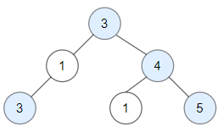

**Input:** root = [3,1,4,3,null,1,5]

**Output:** 4

**Explanation:** Nodes in blue are **good**.

Root Node (3) is always a good node.

Node 4 -> (3,4) is the maximum value in the path starting from the root.

Node 5 -> (3,4,5) is the maximum value in the path

Node 3 -> (3,1,3) is the maximum value in the path.

**Example 2:**

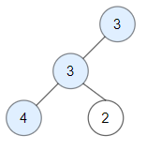

**Input:** root = [3,3,null,4,2]

**Output:** 3

**Explanation:** Node 2 -> (3, 3, 2) is not good, because "3" is higher than it.

**Example 3:**

**Input:** root = [1]

**Output:** 1

**Explanation:** Root is considered as **good**.

**Constraints:**

* The number of nodes in the binary tree is in the range [1, 10^5].
* Each node's value is between [-10^4, 10^4].